UNITED STATES

SECURITIES AND EXCHANGE COMMISSION
Washington, D.C. 20549

SCHEDULE 14A

Proxy Statement Pursuant to Section 14(a)

of the Securities Exchange Act of 1934
(Amendment No. )

Filed by the Registrant ☒ Filed by a Party other than the Registrant ☐

Check the appropriate box:

- Preliminary Proxy Statement

- CONFIDENTIAL, FOR USE OF THE COMMISSION ONLY (AS PERMITTED BY RULE 14A-6(E)(2))

- Definitive Proxy Statement

- Definitive Additional Materials

- Soliciting Material Pursuant to §240.14a-12

Humana Inc.

(Name of Registrant as Specified In Its Charter)

(Name of Person(s) Filing Proxy Statement, if other than the Registrant)

Payment of Filing Fee (Check the appropriate box):

- No fee required.

- Fee paid previously with preliminary materials

- Fee computed on table in exhibit required by Item 25(b) per Exchange Act Rules 14a-6(i)(1) and 0-11

On March 8, 2024, Humana Inc. (the “Company”) made the following communication available to the Company’s employees:

Highlights

- You may have the right to vote on items being presented at our Annual Meeting of Stockholders (the “Annual Meeting”)

- The Company’s Annual Meeting is scheduled for April 18, 2024 at 1:00 p.m. Eastern Time, and will be held via a live audio webcast accessible at: www.virtualshareholdermeeting.com/HUM2024

Exercise your voting privilege as a Humana stockholder

Humana associates who participate in our Company’s Retirement Savings Plan 401(k) and have invested funds in the Humana Common Stock Fund have the right to vote on items being presented at this year’s Annual Meeting, scheduled for April 18, 2024. You may submit one vote for each share held in your Humana Common Stock account as of February 29, 2024, the record date for this Annual Meeting.

What documents do you need to vote?

Every year, Humana produces a document - the proxy statement - that details all of the information the Company’s stockholders need in order to make informed votes. The proxy becomes available to stockholders and the public after Humana files it with the federal Securities and Exchange Commission on March 8, 2024. In order to vote, you must also receive an official “voting card.”

When will you receive the proxy statement and voting card?

Starting March 8, 2024, all stockholders who have (recently or in prior years) successfully submitted electronic requests for a proxy statement and voting card will then receive - via the e-mail address you designated during the online-registration process - a proxy statement and voting card. (Please watch for e-mail from ID@ProxyVote.com.) If you did not sign up for electronic delivery of these materials, you’ll receive a “Notice and Access Card” in the mail at home regarding the material.

When can participants in the Humana Retirement Savings Plan vote?

If you wish to vote, you may do so AFTER you receive your voting card. You then must vote BEFORE 11:59 p.m., EDT on Wednesday, April 10, 2024, through Humana’s Retirement Savings Plan Trustee - Charles Schwab - with Broadridge acting as tabulator. If your voting instructions are received by 11:59 p.m. EDT on Wednesday, April 10, 2024, the Trustee will submit a proxy that reflects your instructions. If you do not give voting instructions (or give them late), the Trustee will vote your interest in the Humana Common Stock Fund in the same proportion as the shares attributed to the Humana Retirement Savings Plan actually voted. Humana’s Annual Meeting will be held on April 18, 2024.

Whom do you contact for answers to your stockholder-voting-process questions?

If you have any questions, please contact Joseph M. Ruschell, Corporate Secretary via email at CorporateSecretary@humana.com.

On March 8, 2024, the Company distributed the following “Notice Regarding the Availability of Proxy Materials” to its stockholders as of the record date of February 29, 2024.



You invested in HUMANA INC. and it’s time to vote!

You have the right to vote on proposals being presented at the Annual Meeting. This is an important notice regarding the availability of proxy material for the stockholder meeting to be held on April 18, 2024.

Get informed before you vote

View the Notice and Proxy Statement and Annual Report online OR you can receive a free paper or email copy of the material(s) by requesting prior to April 4, 2024. If you would like to request a copy of the material(s) for this and/or future stockholder meetings, you may (1) visit www.ProxyVote.com, (2) call 1-800-579-1639 or (3) send an email to sendmaterial@proxyvote.com. If sending an email, please include your control number (indicated below) in the subject line. Unless requested, you will not otherwise receive a paper or email copy.
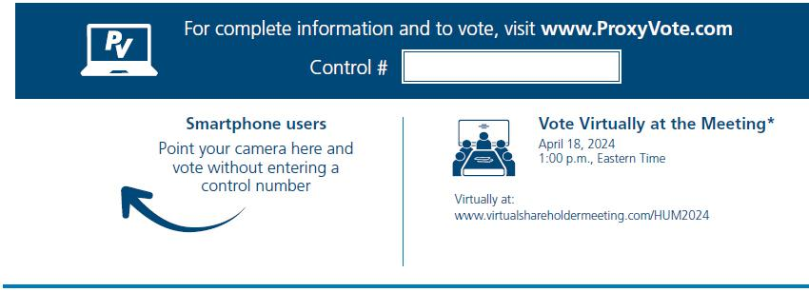

*Please check the meeting materials for any special requirements for meeting attendance.

Vote at www.ProxyVote.com

THIS IS NOT A VOTABLE BALLOT

This is an overview of the proposals being presented at the
upcoming stockholder meeting. Please follow the instructions
on the reverse side to vote these important matters.
 |  |  | Board
Voting Items |  |  | Recommends
1. | Election of Directors
 | Nominees:
1a. | Raquel C. Bono, M.D. |  | For
1b. | Bruce D. Broussard |  | For
1c. | Frank A. D’Amelio |  | For
1d. | David T. Feinberg, M.D. |  | For
1e. | Wayne A. I. Frederick, M.D. |  | For
1f. | John W. Garratt |  | For
1g. | Kurt J. Hilzinger |  | For
1h. | Karen W. Katz |  | For
1i. | Marcy S. Klevorn |  | For
1j. | Jorge S. Mesquita |  | For
1k. | Brad D. Smith |  | For
2. | The ratification of the appointment of Pricewater-houseCoopers LLP as the Company’s independent registered |  | For
2. | public accounting firm. |  | For
3. | Non-binding advisory vote for the approval of the compensation of the named executive officers as disclosed in the |  | For
3. | 2024 proxy statement. |  | For
4. | The approval of the amendment to the Company’s Restated Certificate of Incorporation to limit the liability of |  | For
4. | certain officers of the Company as permitted by Delaware law. |  | For
5. | The approval of the amendment to the Company’s Restated Certificate of Incorporation to eliminate supermajority |  | For
5. | voting requirement in connection with certain transactions. |  | For
6. | The stockholder proposal on simple majority vote, if properly presented at the meeting. |  | Against
At their discretion, the Proxies are authorized to vote upon any other matters as may come before the Annual Meeting.
 | Prefer to receive an email instead? While voting on www.ProxyVote.com, be sure to click “Delivery Settings”.
 | V30287-P02701

